**OUTPUTS**

library(readr)

airlines <- read_csv("D:/r/Internship/w4_day1_day2_mini_project/SixAirlinesDataV2.csv")

View(airlines)

summary(airlines)

Airline Aircraft FlightDuration TravelMonth IsInternational

Length:458 Length:458 Min. : 1.250 Length:458 Length:458

Class :character Class :character 1st Qu.: 4.260 Class :character Class :character

Mode :character Mode :character Median : 7.790 Mode :character Mode :character

Mean : 7.578

3rd Qu.:10.620

Max. :14.660

SeatsEconomy SeatsPremium PitchEconomy PitchPremium WidthEconomy

Min. : 78.0 Min. : 8.00 Min. :30.00 Min. :34.00 Min. :17.00

1st Qu.:133.0 1st Qu.:21.00 1st Qu.:31.00 1st Qu.:38.00 1st Qu.:18.00

Median :185.0 Median :36.00 Median :31.00 Median :38.00 Median :18.00

Mean :202.3 Mean :33.65 Mean :31.22 Mean :37.91 Mean :17.84

3rd Qu.:243.0 3rd Qu.:40.00 3rd Qu.:32.00 3rd Qu.:38.00 3rd Qu.:18.00

Max. :389.0 Max. :66.00 Max. :33.00 Max. :40.00 Max. :19.00

WidthPremium PriceEconomy PricePremium PriceRelative SeatsTotal

Min. :17.00 Min. : 65 Min. : 86.0 Min. :0.0200 Min. : 98

1st Qu.:19.00 1st Qu.: 413 1st Qu.: 528.8 1st Qu.:0.1000 1st Qu.:166

Median :19.00 Median :1242 Median :1737.0 Median :0.3650 Median :227

Mean :19.47 Mean :1327 Mean :1845.3 Mean :0.4872 Mean :236

3rd Qu.:21.00 3rd Qu.:1909 3rd Qu.:2989.0 3rd Qu.:0.7400 3rd Qu.:279

Max. :21.00 Max. :3593 Max. :7414.0 Max. :1.8900 Max. :441

PitchDifference WidthDifference PercentPremiumSeats

Min. : 2.000 Min. :0.000 Min. : 4.71

1st Qu.: 6.000 1st Qu.:1.000 1st Qu.:12.28

Median : 7.000 Median :1.000 Median :13.21

Mean : 6.688 Mean :1.633 Mean :14.65

3rd Qu.: 7.000 3rd Qu.:3.000 3rd Qu.:15.36

Max. :10.000 Max. :4.000 Max. :24.69

Boxplots and corrgrams are drawn to better analyse the data individually

boxplot(airlines$FlightDuration)

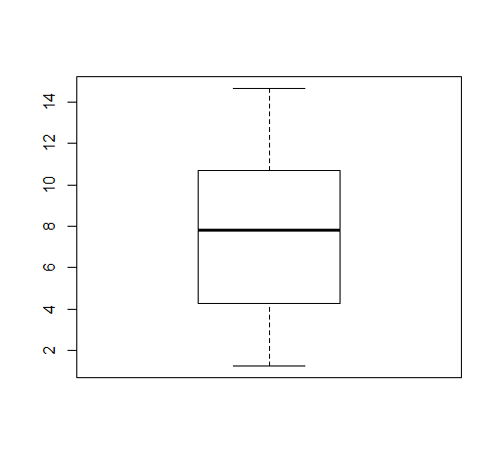

boxplot(airlines$PitchEconomy)

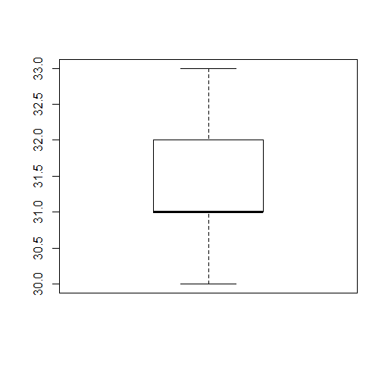

boxplot(airlines$PitchPremium)

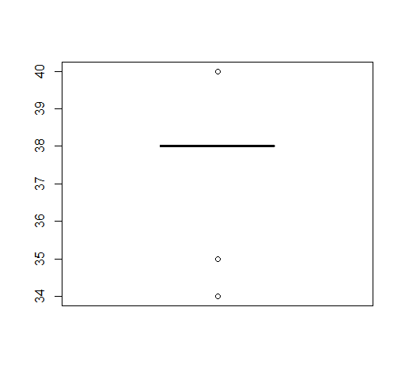

library(corrgram)  
corrgram(mtcars, order=TRUE, lower.panel=panel.shade,  
  upper.panel=panel.pie, text.panel=panel.txt)

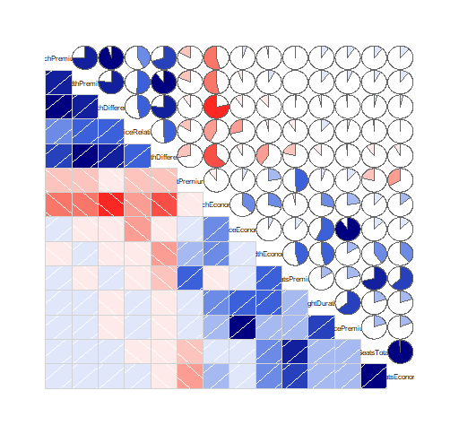

HYPOTHESIS 1:

The flight duration and the Economy price is linearly related.

cor(airlines$FlightDuration,airlines$PriceEconomy)

0.5666404

fit <- lm(PriceEconomy~FlightDuration,data=airlines)

summary(fit)

Call:

lm(formula = PriceEconomy ~ FlightDuration, data = airlines)

Residuals:

Min 1Q Median 3Q Max

-1731.5 -493.2 -156.9 470.9 1863.3

Coefficients:

Estimate Std. Error t value Pr(>|t|)

(Intercept) 129.03 90.04 1.433 0.153

FlightDuration 158.10 10.77 14.685 <2e-16 ***

---

Signif. codes: 0 ‘***’ 0.001 ‘**’ 0.01 ‘*’ 0.05 ‘.’ 0.1 ‘ ’ 1

Residual standard error: 815.2 on 456 degrees of freedom

Multiple R-squared: 0.3211, Adjusted R-squared: 0.3196

F-statistic: 215.7 on 1 and 456 DF, p-value: < 2.2e-16

plot(airlines$FlightDuration,airlines$PriceEconomy,main="There is a correlation between the Price of Economy tickets and the flight duration",xlab="Flight duration",ylab="Price of economy tickets")

abline(fit)

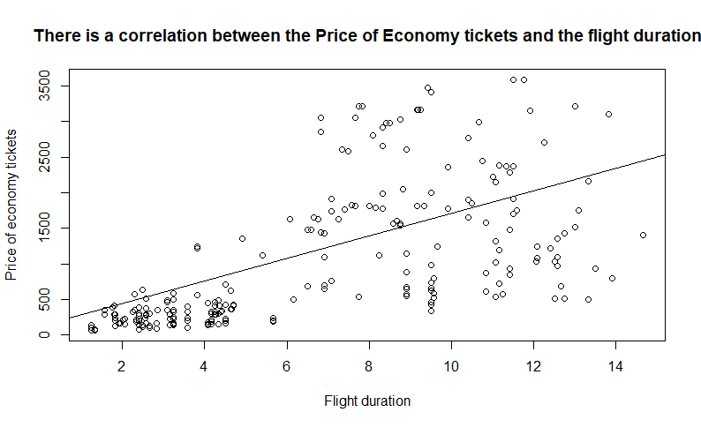

airlines$PriceEconomy

[1] 2707 2707 2707 2707 1793 1793 1793 1476 1476 1705 1705 1911 2378 1750 1750 1750 1813 1813

[19] 1813 1634 1634 1634 1651 1651 1651 1542 1566 1566 1356 1356 1356 1242 1242 1242 1242 940

[37] 940 940 1224 1224 1224 1224 1127 1127 1127 1123 1123 1123 509 509 509 1476 2156 2156

[55] 2156 1634 1634 1634 1038 1038 509 1813 1813 1813 1813 2052 2052 2052 2052 1919 1919 1919

[73] 540 158 189 228 222 216 391 349 581 1444 1444 1444 1444 1824 1824 1824 1823 354

[91] 354 354 354 464 464 464 489 458 2384 2384 2384 2384 1848 1848 1848 1848 1758 1758

[109] 1758 719 719 1198 457 402 402 392 356 356 322 297 303 303 276 249 238 238

[127] 228 231 203 201 207 207 182 171 168 140 147 137 138 126 126 109 109 109

[145] 104 97 77 77 69 74 65 298 423 483 713 574 574 574 574 1086 1086 1086

[163] 1247 1781 1781 1781 1781 1580 1580 1580 1580 1903 1096 2445 2445 2445 2445 975 2369 1811

[181] 1811 1811 1811 1356 1778 1778 1999 1999 1999 1985 1434 1434 1434 1434 1476 1476 1476 1476

[199] 1903 1903 1903 2369 2369 1767 1767 1767 1767 1919 540 540 540 630 743 990 2659 2659

[217] 2659 2659 2659 2659 2659 2659 2607 2607 2607 2860 2860 2609 2609 2609 2813 3165 3165 3165

[235] 3165 3165 3165 3165 3165 1651 1651 2775 2230 2230 2230 2356 2356 2356 2356 1562 1562 1562

[253] 2281 2281 2281 2281 1813 1813 1813 1140 1609 1609 1609 1632 1632 1632 1140 1736 1736 1736

[271] 846 846 937 1485 891 1323 1023 1023 757 533 288 288 363 363 363 413 413 413

[289] 413 413 340 423 328 328 166 166 329 243 243 626 354 293 293 293 636 416

[307] 349 336 429 462 557 557 661 676 794 794 794 794 1215 1215 1215 876 609 609

[325] 1406 1406 1406 1247 1247 1247 563 563 563 563 1431 1431 1431 1431 2918 2918 2918 2581

[343] 2860 3026 3026 3026 3057 3057 3057 3414 3414 3414 3414 3215 3215 3215 3215 3480 3480 3480

[361] 3593 3593 3159 3159 3159 3159 3102 3102 3102 2166 2166 2166 649 575 575 797 524 582

[379] 167 167 167 139 149 197 211 139 118 118 118 108 108 108 297 234 156 156

[397] 324 147 127 154 154 154 154 322 594 648 648 700 1094 505 505 505 505 505

[415] 505 505 505 690 690 690 690 690 690 690 690 1522 1522 2581 2581 2996 2996 2996

[433] 2979 2979 2979 2979 3593 3593 3220 201 148 148 187 187 187 187 245 234 172 172

[451] 172 293 281 295 380 380 505 510

fitted(fit)

1 2 3 4 5 6 7 8 9

2065.7389 2065.7389 2065.7389 2065.7389 1419.1154 1419.1154 1419.1154 1156.6716 1156.6716

10 11 12 13 14 15 16 17 18

1947.1649 1947.1649 1947.1649 1947.1649 1959.8128 1959.8128 1959.8128 1577.2140 1577.2140

19 20 21 22 23 24 25 26 27

1577.2140 1196.1963 1196.1963 1196.1963 1181.9674 1181.9674 1181.9674 1512.3936 1512.3936

28 29 30 31 32 33 34 35 36

1512.3936 905.2948 905.2948 905.2948 734.5482 734.5482 734.5482 734.5482 2263.3622

37 38 39 40 41 42 43 44 45

2263.3622 2263.3622 734.5482 734.5482 734.5482 734.5482 984.3441 984.3441 984.3441

46 47 48 49 50 51 52 53 54

1433.3443 1433.3443 1433.3443 2144.7882 2144.7882 2144.7882 1156.6716 1880.7634 1880.7634

55 56 57 58 59 60 61 62 63

1880.7634 1090.2702 1090.2702 1090.2702 2105.2635 2034.1191 2105.2635 1393.8196 1393.8196

64 65 66 67 68 69 70 71 72

1393.8196 1393.8196 1525.0415 1525.0415 1525.0415 1525.0415 1248.3688 1248.3688 1248.3688

73 74 75 76 77 78 79 80 81

1354.2949 454.7136 497.4003 454.7136 446.8087 497.4003 405.7030 492.6573 492.6573

82 83 84 85 86 87 88 89 90

1208.8442 1208.8442 1208.8442 1208.8442 1327.4182 1327.4182 1327.4182 1327.4182 615.9742

91 92 93 94 95 96 97 98 99

615.9742 615.9742 615.9742 615.9742 615.9742 615.9742 615.9742 802.5306 1893.4113

100 101 102 103 104 105 106 107 108

1893.4113 1893.4113 1893.4113 1789.0662 1789.0662 1789.0662 1789.0662 2196.9607 2196.9607

109 110 111 112 113 114 115 116 117

2196.9607 1893.4113 1893.4113 1893.4113 774.0729 695.0236 695.0236 510.0481 642.8510

118 119 120 121 122 123 124 125 126

642.8510 695.0236 549.5728 510.0481 510.0481 510.0481 642.8510 418.3509 695.0236

127 128 129 130 131 132 133 134 135

840.4743 510.0481 840.4743 418.3509 510.0481 695.0236 774.0729 576.4496 840.4743

136 137 138 139 140 141 142 143 144

326.6537 774.0729 326.6537 510.0481 418.3509 418.3509 326.6537 326.6537 326.6537

145 146 147 148 149 150 151 152 153

695.0236 576.4496 339.3016 339.3016 326.6537 510.0481 339.3016 813.5976 842.0553

154 155 156 157 158 159 160 161 162

813.5976 842.0553 1907.6402 1907.6402 1907.6402 1907.6402 2038.8621 2038.8621 2038.8621

163 164 165 166 167 168 169 170 171

2038.8621 1695.7880 1695.7880 1695.7880 1695.7880 1841.2388 1841.2388 1841.2388 1841.2388

172 173 174 175 176 177 178 179 180

1774.8373 2117.9114 1828.5909 1828.5909 1828.5909 1828.5909 2117.9114 1920.2881 1340.0661

181 182 183 184 185 186 187 188 189

1340.0661 1340.0661 1340.0661 2117.9114 1445.9921 1445.9921 1630.9676 1630.9676 1630.9676

190 191 192 193 194 195 196 197 198

1445.9921 1221.4921 1221.4921 1221.4921 1221.4921 1169.3195 1169.3195 1169.3195 1169.3195

199 200 201 202 203 204 205 206 207

1774.8373 1774.8373 1774.8373 1920.2881 1920.2881 1300.5414 1300.5414 1300.5414 1300.5414

208 209 210 211 212 213 214 215 216

1248.3688 1354.2949 1354.2949 1354.2949 1630.9676 1630.9676 1630.9676 1445.9921 1445.9921

217 218 219 220 221 222 223 224 225

1445.9921 1445.9921 1445.9921 1445.9921 1445.9921 1445.9921 1287.8935 1287.8935 1287.8935

226 227 228 229 230 231 232 233 234

1208.8442 1208.8442 1537.6894 1537.6894 1537.6894 1406.4675 1580.3760 1580.3760 1591.4429

235 236 237 238 239 240 241 242 243

1591.4429 1577.2140 1577.2140 1591.4429 1591.4429 1774.8373 1774.8373 1774.8373 1868.1155

244 245 246 247 248 249 250 251 252

1868.1155 1868.1155 1695.7880 1695.7880 1695.7880 1695.7880 1485.5168 1485.5168 1485.5168

253 254 255 256 257 258 259 260 261

1932.9360 1932.9360 1932.9360 1932.9360 1604.0908 1604.0908 1604.0908 1537.6894 1498.1647

262 263 264 265 266 267 268 269 270

1498.1647 1498.1647 1275.2456 1275.2456 1275.2456 1537.6894 1248.3688 1248.3688 1248.3688

271 272 273 274 275 276 277 278 279

1932.9360 1932.9360 1932.9360 1932.9360 1537.6894 1880.7634 1880.7634 1880.7634 1248.3688

280 281 282 283 284 285 286 287 288

1880.7634 805.6926 800.9497 861.0271 864.1891 865.7701 872.0941 872.0941 872.0941

289 290 291 292 293 294 295 296 297

818.3405 800.9497 829.4074 872.0941 802.5306 824.6645 430.9988 437.3228 486.3333

298 299 300 301 302 303 304 305 306

532.1820 532.1820 861.0271 581.1925 415.1890 418.3509 377.2453 524.2770 413.6080

307 308 309 310 311 312 313 314 315

377.2453 1630.9676 1630.9676 1630.9676 1537.6894 1537.6894 1630.9676 1537.6894 2328.1826

316 317 318 319 320 321 322 323 324

2328.1826 2328.1826 2328.1826 2091.0346 2091.0346 2091.0346 1841.2388 1841.2388 1841.2388

325 326 327 328 329 330 331 332 333

2446.7566 2446.7566 2446.7566 1656.2634 1656.2634 1656.2634 734.5482 734.5482 734.5482

334 335 336 337 338 339 340 341 342

734.5482 2144.7882 2144.7882 2144.7882 2144.7882 1445.9921 1445.9921 1445.9921 1314.7703

343 344 345 346 347 348 349 350 351

1208.8442 1512.3936 1512.3936 1512.3936 1340.0661 1208.8442 1208.8442 1630.9676 1630.9676

352 353 354 355 356 357 358 359 360

1630.9676 1630.9676 1354.2949 1354.2949 1354.2949 1366.9428 1616.7387 1616.7387 1616.7387

361 362 363 364 365 366 367 368 369

1986.6895 1986.6895 2011.9853 2011.9853 2011.9853 2011.9853 2315.5347 2315.5347 2315.5347

370 371 372 373 374 375 376 377 378

2236.4854 2236.4854 2236.4854 1537.6894 1537.6894 1537.6894 1643.6155 1643.6155 1643.6155

379 380 381 382 383 384 385 386 387

642.8510 642.8510 642.8510 642.8510 642.8510 786.7208 786.7208 774.0729 524.2770

388 389 390 391 392 393 394 395 396

524.2770 524.2770 549.5728 549.5728 549.5728 786.7208 642.8510 774.0729 786.7208

397 398 399 400 401 402 403 404 405

786.7208 524.2770 549.5728 813.5976 813.5976 813.5976 813.5976 642.8510 642.8510

406 407 408 409 410 411 412 413 414

1221.4921 1221.4921 1221.4921 1221.4921 2236.4854 2236.4854 2236.4854 2236.4854 1102.9181

415 416 417 418 419 420 421 422 423

1102.9181 1102.9181 1102.9181 2130.5593 2130.5593 2130.5593 2130.5593 1156.6716 1156.6716

424 425 426 427 428 429 430 431 432

1156.6716 1156.6716 2184.3128 2184.3128 1314.7703 1314.7703 1814.3620 1814.3620 1814.3620

433 434 435 436 437 438 439 440 441

1458.6400 1472.8689 1472.8689 1472.8689 1947.1649 1947.1649 2184.3128 1023.8688 628.6221

442 443 444 445 446 447 448 449 450

628.6221 1023.8688 1023.8688 1023.8688 1023.8688 1023.8688 628.6221 536.9249 536.9249

451 452 453 454 455 456 457 458

536.9249 628.6221 536.9249 536.9249 536.9249 536.9249 642.8510 536.9249

residuals(fit)

1 2 3 4 5 6 7

641.261147 641.261147 641.261147 641.261147 373.884623 373.884623 373.884623

8 9 10 11 12 13 14

319.328380 319.328380 -242.164866 -242.164866 -36.164866 430.835134 -209.812758

15 16 17 18 19 20 21

-209.812758 -209.812758 235.785973 235.785973 235.785973 437.803718 437.803718

22 23 24 25 26 27 28

437.803718 469.032596 469.032596 469.032596 29.606420 53.606420 53.606420

29 30 31 32 33 34 35

450.705233 450.705233 450.705233 507.451774 507.451774 507.451774 507.451774

36 37 38 39 40 41 42

-1323.362164 -1323.362164 -1323.362164 489.451774 489.451774 489.451774 489.451774

43 44 45 46 47 48 49

142.655908 142.655908 142.655908 -310.344256 -310.344256 -310.344256 -1635.788178

50 51 52 53 54 55 56

-1635.788178 -1635.788178 319.328380 275.236567 275.236567 275.236567 543.729813

57 58 59 60 61 62 63

543.729813 543.729813 -1067.263515 -996.119123 -1596.263515 419.180406 419.180406

64 65 66 67 68 69 70

419.180406 419.180406 526.958528 526.958528 526.958528 526.958528 670.631164

71 72 73 74 75 76 77

670.631164 670.631164 -814.294931 -296.713617 -308.400252 -226.713617 -224.808684

78 79 80 81 82 83 84

-281.400252 -14.703036 -143.657293 88.342707 235.155826 235.155826 235.155826

85 86 87 88 89 90 91

235.155826 496.581839 496.581839 496.581839 495.581839 -261.974239 -261.974239

92 93 94 95 96 97 98

-261.974239 -261.974239 -151.974239 -151.974239 -151.974239 -126.974239 -344.530645

99 100 101 102 103 104 105

490.588675 490.588675 490.588675 490.588675 58.933783 58.933783 58.933783

106 107 108 109 110 111 112

58.933783 -438.960732 -438.960732 -438.960732 -1174.411325 -1174.411325 -695.411325

113 114 115 116 117 118 119

-317.072888 -293.023564 -293.023564 -118.048144 -286.851010 -286.851010 -373.023564

120 121 122 123 124 125 126

-252.572806 -207.048144 -207.048144 -234.048144 -393.851010 -180.350928 -457.023564

127 128 129 130 131 132 133

-612.474321 -279.048144 -637.474321 -217.350928 -303.048144 -488.023564 -592.072888

134 135 136 137 138 139 140

-405.449577 -672.474321 -186.653711 -627.072888 -189.653711 -372.048144 -292.350928

141 142 143 144 145 146 147

-292.350928 -217.653711 -217.653711 -217.653711 -591.023564 -479.449577 -262.301603

148 149 150 151 152 153 154

-262.301603 -257.653711 -436.048144 -274.301603 -515.597551 -419.055308 -330.597551

155 156 157 158 159 160 161

-129.055308 -1333.640204 -1333.640204 -1333.640204 -1333.640204 -952.862083 -952.862083

162 163 164 165 166 167 168

-952.862083 -791.862083 85.211986 85.211986 85.211986 85.211986 -261.238771

169 170 171 172 173 174 175

-261.238771 -261.238771 -261.238771 128.162662 -1021.911407 616.409121 616.409121

176 177 178 179 180 181 182

616.409121 616.409121 -1142.911407 448.711904 470.933947 470.933947 470.933947

183 184 185 186 187 188 189

470.933947 -761.911407 332.007852 332.007852 368.032433 368.032433 368.032433

190 191 192 193 194 195 196

539.007852 212.507934 212.507934 212.507934 212.507934 306.680488 306.680488

197 198 199 200 201 202 203

306.680488 306.680488 128.162662 128.162662 128.162662 448.711904 448.711904

204 205 206 207 208 209 210

466.458610 466.458610 466.458610 466.458610 670.631164 -814.294931 -814.294931

211 212 213 214 215 216 217

-814.294931 -1000.967567 -887.967567 -640.967567 1213.007852 1213.007852 1213.007852

218 219 220 221 222 223 224

1213.007852 1213.007852 1213.007852 1213.007852 1213.007852 1319.106501 1319.106501

225 226 227 228 229 230 231

1319.106501 1651.155826 1651.155826 1071.310636 1071.310636 1071.310636 1406.532515

232 233 234 235 236 237 238

1584.624000 1584.624000 1573.557095 1573.557095 1587.785973 1587.785973 1573.557095

239 240 241 242 243 244 245

1573.557095 -123.837338 -123.837338 1000.162662 361.884459 361.884459 361.884459

246 247 248 249 250 251 252

660.211986 660.211986 660.211986 660.211986 76.483190 76.483190 76.483190

253 254 255 256 257 258 259

348.064012 348.064012 348.064012 348.064012 208.909203 208.909203 208.909203

260 261 262 263 264 265 266

-397.689364 110.835298 110.835298 110.835298 356.754393 356.754393 356.754393

267 268 269 270 271 272 273

-397.689364 487.631164 487.631164 487.631164 -1086.935988 -1086.935988 -995.935988

274 275 276 277 278 279 280

-447.935988 -646.689364 -557.763433 -857.763433 -857.763433 -491.368836 -1347.763433

281 282 283 284 285 286 287

-517.692618 -512.949659 -498.027146 -501.189118 -502.770105 -459.094051 -459.094051

288 289 290 291 292 293 294

-459.094051 -405.340510 -387.949659 -489.407416 -449.094051 -474.530645 -496.664456

295 296 297 298 299 300 301

-264.998820 -271.322765 -157.333347 -289.181955 -289.181955 -235.027146 -227.192536

302 303 304 305 306 307 308

-122.188955 -125.350928 -84.245279 111.722977 2.392032 -28.245279 -1294.967567

309 310 311 312 313 314 315

-1201.967567 -1168.967567 -980.689364 -980.689364 -969.967567 -861.689364 -1534.182611

316 317 318 319 320 321 322

-1534.182611 -1534.182611 -1534.182611 -876.034637 -876.034637 -876.034637 -965.238771

323 324 325 326 327 328 329

-1232.238771 -1232.238771 -1040.756598 -1040.756598 -1040.756598 -409.263351 -409.263351

330 331 332 333 334 335 336

-409.263351 -171.548226 -171.548226 -171.548226 -171.548226 -713.788178 -713.788178

337 338 339 340 341 342 343

-713.788178 -713.788178 1472.007852 1472.007852 1472.007852 1266.229731 1651.155826

344 345 346 347 348 349 350

1513.606420 1513.606420 1513.606420 1716.933947 1848.155826 1848.155826 1783.032433

351 352 353 354 355 356 357

1783.032433 1783.032433 1783.032433 1860.705069 1860.705069 1860.705069 1848.057177

358 359 360 361 362 363 364

1863.261311 1863.261311 1863.261311 1606.310472 1606.310472 1147.014688 1147.014688

365 366 367 368 369 370 371

1147.014688 1147.014688 786.465281 786.465281 786.465281 -70.485394 -70.485394

372 373 374 375 376 377 378

-70.485394 -888.689364 -962.689364 -962.689364 -846.615459 -1119.615459 -1061.615459

379 380 381 382 383 384 385

-475.851010 -475.851010 -475.851010 -503.851010 -493.851010 -589.720780 -575.720780

386 387 388 389 390 391 392

-635.072888 -406.277023 -406.277023 -406.277023 -441.572806 -441.572806 -441.572806

393 394 395 396 397 398 399

-489.720780 -408.851010 -618.072888 -630.720780 -462.720780 -377.277023 -422.572806

400 401 402 403 404 405 406

-659.597551 -659.597551 -659.597551 -659.597551 -320.851010 -48.851010 -573.492066

407 408 409 410 411 412 413

-573.492066 -521.492066 -127.492066 -1731.485394 -1731.485394 -1731.485394 -1731.485394

414 415 416 417 418 419 420

-597.918079 -597.918079 -597.918079 -597.918079 -1440.559299 -1440.559299 -1440.559299

421 422 423 424 425 426 427

-1440.559299 -466.671620 -466.671620 -466.671620 -466.671620 -662.312840 -662.312840

428 429 430 431 432 433 434

1266.229731 1266.229731 1181.637999 1181.637999 1181.637999 1520.359960 1506.131082

435 436 437 438 439 440 441

1506.131082 1506.131082 1645.835134 1645.835134 1035.687160 -822.868754 -480.622131

442 443 444 445 446 447 448

-480.622131 -836.868754 -836.868754 -836.868754 -836.868754 -778.868754 -394.622131

449 450 451 452 453 454 455

-364.924915 -364.924915 -364.924915 -335.622131 -255.924915 -241.924915 -156.924915

456 457 458

-156.924915 -137.851010 -26.924915

**Regression model formulated is**

**PriceEconomy= 158.10 (FlightDuration) + 129.03**

confint(fit)

2.5 % 97.5 %

(Intercept) -47.90709 305.9679

FlightDuration 136.94188 179.2554

T-test

*H0 is that the difference between the means of the flight duration and the Economy Price should be EQUAL to zero.*

*H1 says the difference between the means of the Economy Price and the flight duration is NOT EQUAL to zero.*

t.test(airlines$PriceEconomy,airlines$FlightDuration)

Welch Two Sample t-test

data: airlines$PriceEconomy and airlines$FlightDuration

t = 28.573, df = 457.01, p-value < 2.2e-16

alternative hypothesis: true difference in means is not equal to 0

95 percent confidence interval:

1228.749 1410.249

sample estimates:

mean of x mean of y

1327.076419 7.577838

**The p value is very very less than 0.05 which is chosen as the threshold, therefore we reject the null hypothesis.**

HYPOTHESIS 2:

The flight duration and the Premium Price is linearly related.

cor(airlines$FlightDuration,airlines$PriceEconomy)

0.6487398

fit <- lm(PricePremium~FlightDuration,data=airlines)

summary(fit)

Call:

lm(formula = PricePremium ~ FlightDuration, data = airlines)

Residuals:

Min 1Q Median 3Q Max

-2292.5 -664.7 -103.8 803.0 4093.7

Coefficients:

Estimate Std. Error t value Pr(>|t|)

(Intercept) 57.45 108.39 0.53 0.596

FlightDuration 235.93 12.96 18.20 <2e-16 ***

---

Signif. codes: 0 ‘***’ 0.001 ‘**’ 0.01 ‘*’ 0.05 ‘.’ 0.1 ‘ ’ 1

Residual standard error: 981.4 on 456 degrees of freedom

Multiple R-squared: 0.4209, Adjusted R-squared: 0.4196

F-statistic: 331.4 on 1 and 456 DF, p-value: < 2.2e-16

plot(airlines$FlightDuration,airlines$PricePremium,main="There is a correlation between the Price of Premium tickets and the flight duration",xlab="Flight duration",ylab="Price of Premium tickets")

abline(fit)

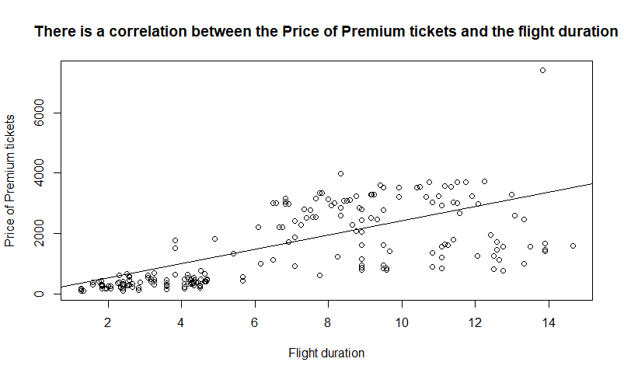

airlines$PricePremium

[1] 3725 3725 3725 3725 2999 2999 2999 2997 2997 2989 2989 2989 2989 2656 2656 2656 2504 2504

[19] 2504 2195 2195 2195 2191 2191 2191 2084 2084 2084 1820 1820 1820 1764 1764 1764 1764 1548

[37] 1548 1548 1512 1512 1512 1512 1317 1317 1317 1213 1213 1213 773 773 773 2997 2933 2933

[55] 2933 2195 2195 2195 1259 1259 818 3128 3128 3128 3128 2856 2856 2856 2856 2409 2409 2409

[73] 594 173 204 243 237 231 406 364 596 2982 2982 2982 2982 2549 2549 2549 2548 524

[91] 524 524 524 616 616 616 616 497 3563 3563 3563 3563 3536 3536 3536 3536 2592 2592

[109] 2592 1634 1634 1634 486 442 442 407 396 396 348 323 319 319 306 285 278 276

[127] 263 247 238 237 237 234 211 201 198 175 175 172 165 156 156 141 141 141

[145] 131 125 99 99 97 97 86 337 467 527 757 1619 1619 1619 1619 2964 2964 2964

[163] 2964 3509 3509 3509 3509 3019 3019 3019 3019 3509 1710 3694 3694 3694 3694 1465 3540 2531

[181] 2531 2531 2531 1710 2588 2588 2765 2765 2765 2588 2982 2982 2982 2982 2997 2997 2997 2997

[199] 3509 3509 3509 3540 3540 2499 2499 2499 2499 2409 594 594 594 1611 1611 1611 2859 2859

[217] 2859 2859 2859 2859 2859 2859 2807 2807 2807 3063 3063 2787 2787 2787 2922 3275 3275 3275

[235] 3275 3275 3275 3275 3275 3509 3509 3509 3227 3227 3227 3200 3200 3200 3200 3099 3099 3099

[253] 3025 3025 3025 3025 2472 2472 2472 2423 2292 2292 2292 2278 2278 2278 2049 1866 1866 1866

[271] 1784 1784 1784 1784 1603 1550 1199 1199 912 837 327 327 407 407 407 457 457 457

[289] 457 457 379 467 362 362 181 181 354 262 262 670 378 308 308 308 660 431

[307] 364 841 841 841 789 789 928 931 1671 1452 1452 1408 1947 1947 1947 1356 900 900

[325] 1584 1584 1584 1407 1407 1407 619 619 619 619 1564 1564 1564 1564 3972 3972 3972 2781

[343] 3063 3226 3226 3226 3167 3167 3167 3524 3524 3524 3524 3325 3325 3325 3325 3589 3589 3589

[361] 3702 3702 3243 3243 3243 3243 7414 7414 7414 2470 2470 2470 1152 853 853 826 797 797

[379] 483 483 483 398 398 520 534 318 267 267 267 228 228 228 620 483 318 318

[397] 620 267 228 267 267 267 267 483 696 1710 1710 1710 1710 1004 1004 1004 1004 1004

[415] 1004 1004 1004 1110 1110 1110 1110 1110 1110 1110 1110 3289 3289 2781 2781 3196 3196 3196

[433] 3088 3088 3088 3088 3702 3702 3289 545 397 397 430 430 430 430 545 483 304 304

[451] 304 483 451 464 550 550 696 569

fitted(fit)

1 2 3 4 5 6 7 8 9

2947.5417 2947.5417 2947.5417 2947.5417 1982.6047 1982.6047 1982.6047 1590.9676 1590.9676

10 11 12 13 14 15 16 17 18

2770.5973 2770.5973 2770.5973 2770.5973 2789.4714 2789.4714 2789.4714 2218.5306 2218.5306

19 20 21 22 23 24 25 26 27

2218.5306 1649.9491 1649.9491 1649.9491 1628.7158 1628.7158 1628.7158 2121.8010 2121.8010

28 29 30 31 32 33 34 35 36

2121.8010 1215.8454 1215.8454 1215.8454 961.0453 961.0453 961.0453 961.0453 3242.4492

37 38 39 40 41 42 43 44 45

3242.4492 3242.4492 961.0453 961.0453 961.0453 961.0453 1333.8083 1333.8083 1333.8083

46 47 48 49 50 51 52 53 54

2003.8380 2003.8380 2003.8380 3065.5047 3065.5047 3065.5047 1590.9676 2671.5084 2671.5084

55 56 57 58 59 60 61 62 63

2671.5084 1491.8787 1491.8787 1491.8787 3006.5232 2900.3566 3006.5232 1944.8565 1944.8565

64 65 66 67 68 69 70 71 72

1944.8565 1944.8565 2140.6750 2140.6750 2140.6750 2140.6750 1727.8046 1727.8046 1727.8046

73 74 75 76 77 78 79 80 81

1885.8750 543.4564 607.1564 543.4564 531.6601 607.1564 470.3194 600.0787 600.0787

82 83 84 85 86 87 88 89 90

1668.8232 1668.8232 1668.8232 1668.8232 1845.7676 1845.7676 1845.7676 1845.7676 784.1009

91 92 93 94 95 96 97 98 99

784.1009 784.1009 784.1009 784.1009 784.1009 784.1009 784.1009 1062.4935 2690.3825

100 101 102 103 104 105 106 107 108

2690.3825 2690.3825 2690.3825 2534.6713 2534.6713 2534.6713 2534.6713 3143.3603 3143.3603

109 110 111 112 113 114 115 116 117

3143.3603 2690.3825 2690.3825 2690.3825 1020.0268 902.0639 902.0639 626.0305 824.2083

118 119 120 121 122 123 124 125 126

824.2083 902.0639 685.0120 626.0305 626.0305 626.0305 824.2083 489.1935 902.0639

127 128 129 130 131 132 133 134 135

1119.1157 626.0305 1119.1157 489.1935 626.0305 902.0639 1020.0268 725.1194 1119.1157

136 137 138 139 140 141 142 143 144

352.3564 1020.0268 352.3564 626.0305 489.1935 489.1935 352.3564 352.3564 352.3564

145 146 147 148 149 150 151 152 153

902.0639 725.1194 371.2305 371.2305 352.3564 626.0305 371.2305 1079.0083 1121.4750

154 155 156 157 158 159 160 161 162

1079.0083 1121.4750 2711.6158 2711.6158 2711.6158 2711.6158 2907.4343 2907.4343 2907.4343

163 164 165 166 167 168 169 170 171

2907.4343 2395.4750 2395.4750 2395.4750 2395.4750 2612.5269 2612.5269 2612.5269 2612.5269

172 173 174 175 176 177 178 179 180

2513.4380 3025.3973 2593.6528 2593.6528 2593.6528 2593.6528 3025.3973 2730.4899 1864.6417

181 182 183 184 185 186 187 188 189

1864.6417 1864.6417 1864.6417 3025.3973 2022.7121 2022.7121 2298.7454 2298.7454 2298.7454

190 191 192 193 194 195 196 197 198

2022.7121 1687.6972 1687.6972 1687.6972 1687.6972 1609.8417 1609.8417 1609.8417 1609.8417

199 200 201 202 203 204 205 206 207

2513.4380 2513.4380 2513.4380 2730.4899 2730.4899 1805.6602 1805.6602 1805.6602 1805.6602

208 209 210 211 212 213 214 215 216

1727.8046 1885.8750 1885.8750 1885.8750 2298.7454 2298.7454 2298.7454 2022.7121 2022.7121

217 218 219 220 221 222 223 224 225

2022.7121 2022.7121 2022.7121 2022.7121 2022.7121 2022.7121 1786.7861 1786.7861 1786.7861

226 227 228 229 230 231 232 233 234

1668.8232 1668.8232 2159.5491 2159.5491 2159.5491 1963.7306 2223.2491 2223.2491 2239.7639

235 236 237 238 239 240 241 242 243

2239.7639 2218.5306 2218.5306 2239.7639 2239.7639 2513.4380 2513.4380 2513.4380 2652.6343

244 245 246 247 248 249 250 251 252

2652.6343 2652.6343 2395.4750 2395.4750 2395.4750 2395.4750 2081.6935 2081.6935 2081.6935

253 254 255 256 257 258 259 260 261

2749.3640 2749.3640 2749.3640 2749.3640 2258.6380 2258.6380 2258.6380 2159.5491 2100.5676

262 263 264 265 266 267 268 269 270

2100.5676 2100.5676 1767.9121 1767.9121 1767.9121 2159.5491 1727.8046 1727.8046 1727.8046

271 272 273 274 275 276 277 278 279

2749.3640 2749.3640 2749.3640 2749.3640 2159.5491 2671.5084 2671.5084 2671.5084 1727.8046

280 281 282 283 284 285 286 287 288

2671.5084 1067.2120 1060.1342 1149.7861 1154.5046 1156.8639 1166.3009 1166.3009 1166.3009

289 290 291 292 293 294 295 296 297

1086.0861 1060.1342 1102.6009 1166.3009 1062.4935 1095.5231 508.0676 517.5046 590.6416

298 299 300 301 302 303 304 305 306

659.0602 659.0602 1149.7861 732.1972 484.4750 489.1935 427.8527 647.2639 482.1157

307 308 309 310 311 312 313 314 315

427.8527 2298.7454 2298.7454 2298.7454 2159.5491 2159.5491 2298.7454 2159.5491 3339.1788

316 317 318 319 320 321 322 323 324

3339.1788 3339.1788 3339.1788 2985.2899 2985.2899 2985.2899 2612.5269 2612.5269 2612.5269

325 326 327 328 329 330 331 332 333

3516.1232 3516.1232 3516.1232 2336.4936 2336.4936 2336.4936 961.0453 961.0453 961.0453

334 335 336 337 338 339 340 341 342

961.0453 3065.5047 3065.5047 3065.5047 3065.5047 2022.7121 2022.7121 2022.7121 1826.8935

343 344 345 346 347 348 349 350 351

1668.8232 2121.8010 2121.8010 2121.8010 1864.6417 1668.8232 1668.8232 2298.7454 2298.7454

352 353 354 355 356 357 358 359 360

2298.7454 2298.7454 1885.8750 1885.8750 1885.8750 1904.7491 2277.5121 2277.5121 2277.5121

361 362 363 364 365 366 367 368 369

2829.5788 2829.5788 2867.3269 2867.3269 2867.3269 2867.3269 3320.3047 3320.3047 3320.3047

370 371 372 373 374 375 376 377 378

3202.3417 3202.3417 3202.3417 2159.5491 2159.5491 2159.5491 2317.6195 2317.6195 2317.6195

379 380 381 382 383 384 385 386 387

824.2083 824.2083 824.2083 824.2083 824.2083 1038.9009 1038.9009 1020.0268 647.2639

388 389 390 391 392 393 394 395 396

647.2639 647.2639 685.0120 685.0120 685.0120 1038.9009 824.2083 1020.0268 1038.9009

397 398 399 400 401 402 403 404 405

1038.9009 647.2639 685.0120 1079.0083 1079.0083 1079.0083 1079.0083 824.2083 824.2083

406 407 408 409 410 411 412 413 414

1687.6972 1687.6972 1687.6972 1687.6972 3202.3417 3202.3417 3202.3417 3202.3417 1510.7528

415 416 417 418 419 420 421 422 423

1510.7528 1510.7528 1510.7528 3044.2714 3044.2714 3044.2714 3044.2714 1590.9676 1590.9676

424 425 426 427 428 429 430 431 432

1590.9676 1590.9676 3124.4862 3124.4862 1826.8935 1826.8935 2572.4195 2572.4195 2572.4195

433 434 435 436 437 438 439 440 441

2041.5861 2062.8195 2062.8195 2062.8195 2770.5973 2770.5973 3124.4862 1392.7898 802.9750

442 443 444 445 446 447 448 449 450

802.9750 1392.7898 1392.7898 1392.7898 1392.7898 1392.7898 802.9750 666.1379 666.1379

451 452 453 454 455 456 457 458

666.1379 802.9750 666.1379 666.1379 666.1379 666.1379 824.2083 666.1379

residuals(fit)

1 2 3 4 5 6 7

777.458262 777.458262 777.458262 777.458262 1016.395344 1016.395344 1016.395344

8 9 10 11 12 13 14

1406.032399 1406.032399 218.402715 218.402715 218.402715 218.402715 -133.471360

15 16 17 18 19 20 21

-133.471360 -133.471360 285.469407 285.469407 285.469407 545.050915 545.050915

22 23 24 25 26 27 28

545.050915 562.284249 562.284249 562.284249 -37.800959 -37.800959 -37.800959

29 30 31 32 33 34 35

604.154638 604.154638 604.154638 802.954650 802.954650 802.954650 802.954650

36 37 38 39 40 41 42

-1694.449159 -1694.449159 -1694.449159 550.954650 550.954650 550.954650 550.954650

43 44 45 46 47 48 49

-16.808330 -16.808330 -16.808330 -790.837990 -790.837990 -790.837990 -2292.504706

50 51 52 53 54 55 56

-2292.504706 -2292.504706 1406.032399 261.491608 261.491608 261.491608 703.121292

57 58 59 60 61 62 63

703.121292 703.121292 -1747.523222 -1641.356550 -2188.523222 1183.143494 1183.143494

64 65 66 67 68 69 70

1183.143494 1183.143494 715.324966 715.324966 715.324966 715.324966 681.195356

71 72 73 74 75 76 77

681.195356 681.195356 -1291.875022 -370.456442 -403.156445 -300.456442 -294.660145

78 79 80 81 82 83 84

-376.156445 -64.319401 -236.078666 -4.078666 1313.176840 1313.176840 1313.176840

85 86 87 88 89 90 91

1313.176840 703.232387 703.232387 703.232387 702.232387 -260.100897 -260.100897

92 93 94 95 96 97 98

-260.100897 -260.100897 -168.100897 -168.100897 -168.100897 -168.100897 -565.493503

99 100 101 102 103 104 105

872.617533 872.617533 872.617533 872.617533 1001.328652 1001.328652 1001.328652

106 107 108 109 110 111 112

1001.328652 -551.360265 -551.360265 -551.360265 -1056.382467 -1056.382467 -1056.382467

113 114 115 116 117 118 119

-534.026834 -460.063866 -460.063866 -219.030520 -428.208306 -428.208306 -554.063866

120 121 122 123 124 125 126

-362.012004 -307.030520 -307.030520 -320.030520 -539.208306 -211.193476 -626.063866

127 128 129 130 131 132 133

-856.115727 -379.030520 -881.115727 -252.193476 -389.030520 -668.063866 -809.026834

134 135 136 137 138 139 140

-524.119413 -921.115727 -177.356433 -845.026834 -180.356433 -461.030520 -333.193476

141 142 143 144 145 146 147

-333.193476 -211.356433 -211.356433 -211.356433 -771.063866 -600.119413 -272.230508

148 149 150 151 152 153 154

-272.230508 -255.356433 -529.030520 -285.230508 -742.008318 -654.474987 -552.008318

155 156 157 158 159 160 161

-364.474987 -1092.615801 -1092.615801 -1092.615801 -1092.615801 56.565672 56.565672

162 163 164 165 166 167 168

56.565672 56.565672 1113.524954 1113.524954 1113.524954 1113.524954 406.473093

169 170 171 172 173 174 175

406.473093 406.473093 406.473093 995.561986 -1315.397297 1100.347167 1100.347167

176 177 178 179 180 181 182

1100.347167 1100.347167 -1560.397297 809.510124 666.358312 666.358312 666.358312

183 184 185 186 187 188 189

666.358312 -1315.397297 565.287935 565.287935 466.254588 466.254588 466.254588

190 191 192 193 194 195 196

565.287935 1294.302765 1294.302765 1294.302765 1294.302765 1387.158324 1387.158324

197 198 199 200 201 202 203

1387.158324 1387.158324 995.561986 995.561986 995.561986 809.510124 809.510124

204 205 206 207 208 209 210

693.339796 693.339796 693.339796 693.339796 681.195356 -1291.875022 -1291.875022

211 212 213 214 215 216 217

-1291.875022 -687.745412 -687.745412 -687.745412 836.287935 836.287935 836.287935

218 219 220 221 222 223 224

836.287935 836.287935 836.287935 836.287935 836.287935 1020.213871 1020.213871

225 226 227 228 229 230 231

1020.213871 1394.176840 1394.176840 627.450891 627.450891 627.450891 958.269419

232 233 234 235 236 237 238

1051.750888 1051.750888 1035.236073 1035.236073 1056.469407 1056.469407 1035.236073

239 240 241 242 243 244 245

1035.236073 995.561986 995.561986 995.561986 574.365683 574.365683 574.365683

246 247 248 249 250 251 252

804.524954 804.524954 804.524954 804.524954 1017.306450 1017.306450 1017.306450

253 254 255 256 257 258 259

275.636049 275.636049 275.636049 275.636049 213.361998 213.361998 213.361998

260 261 262 263 264 265 266

263.450891 191.432375 191.432375 191.432375 510.087946 510.087946 510.087946

267 268 269 270 271 272 273

-110.549109 138.195356 138.195356 138.195356 -965.363951 -965.363951 -965.363951

274 275 276 277 278 279 280

-965.363951 -556.549109 -1121.508392 -1472.508392 -1472.508392 -815.804644 -1834.508392

281 282 283 284 285 286 287

-740.212021 -733.134243 -742.786099 -747.504618 -749.863877 -709.300915 -709.300915

288 289 290 291 292 293 294

-709.300915 -629.086096 -603.134243 -723.600912 -699.300915 -700.493503 -733.523134

295 296 297 298 299 300 301

-327.067551 -336.504589 -236.641629 -397.060151 -397.060151 -479.786099 -354.197191

302 303 304 305 306 307 308

-176.474957 -181.193476 -119.852733 12.736146 -51.115698 -63.852733 -1457.745412

309 310 311 312 313 314 315

-1457.745412 -1457.745412 -1370.549109 -1370.549109 -1370.745412 -1228.549109 -1668.178793

316 317 318 319 320 321 322

-1887.178793 -1887.178793 -1931.178793 -1038.289888 -1038.289888 -1038.289888 -1256.526907

323 324 325 326 327 328 329

-1712.526907 -1712.526907 -1932.123245 -1932.123245 -1932.123245 -929.493561 -929.493561

330 331 332 333 334 335 336

-929.493561 -342.045350 -342.045350 -342.045350 -342.045350 -1501.504706 -1501.504706

337 338 339 340 341 342 343

-1501.504706 -1501.504706 1949.287935 1949.287935 1949.287935 954.106462 1394.176840

344 345 346 347 348 349 350

1104.199041 1104.199041 1104.199041 1302.358312 1498.176840 1498.176840 1225.254588

351 352 353 354 355 356 357

1225.254588 1225.254588 1225.254588 1439.124978 1439.124978 1439.124978 1420.250903

358 359 360 361 362 363 364

1311.487923 1311.487923 1311.487923 872.421231 872.421231 375.673081 375.673081

365 366 367 368 369 370 371

375.673081 375.673081 4093.695282 4093.695282 4093.695282 -732.341750 -732.341750

372 373 374 375 376 377 378

-732.341750 -1007.549109 -1306.549109 -1306.549109 -1491.619486 -1520.619486 -1520.619486

379 380 381 382 383 384 385

-341.208306 -341.208306 -341.208306 -426.208306 -426.208306 -518.900909 -504.900909

386 387 388 389 390 391 392

-702.026834 -380.263854 -380.263854 -380.263854 -457.012004 -457.012004 -457.012004

393 394 395 396 397 398 399

-418.900909 -341.208306 -702.026834 -720.900909 -418.900909 -380.263854 -457.012004

400 401 402 403 404 405 406

-812.008318 -812.008318 -812.008318 -812.008318 -341.208306 -128.208306 22.302765

407 408 409 410 411 412 413

22.302765 22.302765 22.302765 -2198.341750 -2198.341750 -2198.341750 -2198.341750

414 415 416 417 418 419 420

-506.752783 -506.752783 -506.752783 -506.752783 -1934.271372 -1934.271372 -1934.271372

421 422 423 424 425 426 427

-1934.271372 -480.967601 -480.967601 -480.967601 -480.967601 164.513810 164.513810

428 429 430 431 432 433 434

954.106462 954.106462 623.580502 623.580502 623.580502 1046.413860 1025.180525

435 436 437 438 439 440 441

1025.180525 1025.180525 931.402715 931.402715 164.513810 -847.789814 -405.974972

442 443 444 445 446 447 448

-405.974972 -962.789814 -962.789814 -962.789814 -962.789814 -847.789814 -319.974972

449 450 451 452 453 454 455

-362.137929 -362.137929 -362.137929 -319.974972 -215.137929 -202.137929 -116.137929

456 457 458

-116.137929 -128.208306 -97.137929

**Regression model formulated is**

**PricePremium= 235.92594 (FlightDuration) + 57.44901**

confint(fit)

2.5 % 97.5 %

(Intercept) -155.5541 270.4522

FlightDuration 210.4567 261.3952

T-test

*H0 is that the difference between the means of the flight duration and the Premium Price should be EQUAL to zero.*

*H1 says the difference between the means of the Premium Price and the flight duration is NOT EQUAL to zero.*

t.test(airlines$PricePremium,airlines$FlightDuration)

Welch Two Sample t-test

data: airlines$PricePremium and airlines$FlightDuration

t = 30.531, df = 457.01, p-value < 2.2e-16

alternative hypothesis: true difference in means is not equal to 0

95 percent confidence interval:

1719.395 1955.965

sample estimates:

mean of x mean of y

1845.257642 7.577838

**The p value is very very less than 0.05 which is chosen as the threshold, therefore we reject the null hypothesis.**